Grade 7 Mandarin Chinese
Length of Course: Full Year

Course Description: Mandarin Chinese Intermediate Level
In this course, students will develop communicative competence in the Mandarin Chinese language in all language skills: listening, speaking, reading, and writing. Students will practice their language in interpretive, interpersonal, and interpretive modes via communicative speaking and writing activities, listening to authentic Chinese speakers, and perform a skit written by students themselves. Cultural topics focus on the Chinese school systems, making phone call manners, and different community.

UNIT 1: Countries, Weather, and Seasons
Big Ideas: By learning this unit, students can make a plan to travel the world according to the different weather patterns. Geography and weather are closely associated with each other and have impact on family vacations.

Essential Questions  - How does weather affect planning a trip to another country?  - What are some common weather patterns?  - How do we use vocabulary, phrases and sentences to express things we have done?  assertive sentence: v.+ 过  negative sentence： 没（有）v.+ 过  - How to conduct a conversation asking and answering questions about weather and plan the trip accordingly.  Students will ask about weather: 北京天气怎么样？Describe the weather: 很冷、热; What clothes to wear: 我穿什么衣服。 | Enduring Understandings  Students will understand that...  - Studying another language and cultures offers insight of their own.  - The geographical location of a place affects the weather of that area.  - Planning a trip to a certain country needs the planner to take weather into consideration.  - Most countries in Chinese language are translated from the sound and with 国 at the end.  - Create a sentence by telling what the person has done with whom in somewhere. E.g. 我跟爸爸去过英国。
Areas of Focus: Proficiencies  (Cumulative Progress Indicators)  Students will:  7.1.IL.A.2 Demonstrate comprehension of oral and written instructions connected to daily activities through appropriate responses.  7.1.IL.A.4  Use the target language to describe people, places, objects, and daily activities learned about through oral or written descriptions.  7.1.IL.B.1 Use digital tools to participate in short conversations and to exchange information related to targeted themes.  7.1.IL.B.5 Engage in short conversations about personal experiences or events and/or topics studied in other content areas.  7.1.IL.C.1 Use knowledge about cultural products and cultural practices to create a multimedia-rich presentation on targeted themes to be shared virtually with a target language audience.  7.1.IL.C.2  Present student-created and/or authentic short plays, skits, poems, songs, stories, or reports.  7.1.IL.C.4  Compare and contrast age- and level-appropriate culturally authentic materials orally and in writing. | Examples, Outcomes, Assessments  Instructional Focus:  - apply the weather vocabulary, phrases, and sentences to describe weather.  - express things we have done  assertive sentence：v.+ 过  negative sentence： 没（有）v.+ 过  - compare the differences or similarities of weather between American and Chinese cities.  - describe the seasonal weather by stating seasonal colors and giving suggestions about what clothes to wear in each season in different cities  - conduct a conversation and ask questions about weather and plan the trip accordingly  - Distinguish 跟 (with) and 和（and）  - When a sentence has a place and a person, it need to follow Person + Time + Place+Verb  Sample Assessments:  - written vocabulary quiz  - season project requires students to include each season’s color, months, and suggestion about what to wear  - oral assessment need students to talk about weather and seasons  - Write and perform a travel agent and customer skit (include greetings, countries and cities, and weather and season information)  - Create a survey “have you ever done …” and ask and answer peers questions  Instructional Strategies:  Interpretive:  - Use total Physical Response activities and pictures to acquire vocabulary and phrases on weather and seasons.  - Use radicals in characters as a clue to decode the meanings of new characters.  - Vocabulary dictation practices  - Weather report listening practice  - Read a weather forecast paragraph and finish a reading comprehension  - Sing a country song  - Fill out a survey about “have you ever done …”  Interpersonal:  - Write and perform a travel agent and customer skit (include greetings, countries and cities, and weather and season information)  - Create a survey “have you ever done …” and ask and answer peers questions  - Discuss with group members to compare whether Beijing or Summit’s weather is better for people to live in.  Presentational:  - Finish written vocabulary quiz  - season project requires students to include each season’s color, months, and suggestion about what to wear  - provided with a weather forecast chart, students will take an oral assessment describing weather and seasons  - Write and perform a travel agent and customer skit (include greetings, countries and cities, and weather and season information)  Interdisciplinary Connections  - Geography: Students learn where different countries are on Google Map; how weather and season varies in different places of the world  - Social Studies: Student learn different countries speak different languages.  - Math: Students learn how to convert Fahrenheit to Celsius.  Technology Integration  - Google Map: students use Google map to explore different places in this word  - Google Classroom: to write out scripts and post assignments.  - World Map Extension: Students pull up a 3D world map on Chromebook and get familiar with some countries of this world  - Use of a YouTube song for students to get familiar with even more countries in the world  Global Perspectives  - Students will be able to understand why some countries’ name in Chinese are in that way. E.g. 法国 (France) is from the translation; 日本（Japan）is from Kanji characters in Chinese  Culturally Responsive Teaching  - Students will have a general understanding of where some countries are regarding to America.

Additional Resources:
Talking Tom Weather Report: https://www.youtube.com/watch?v=efXkgbfHBzw
Learn Seasons with Emma: http://www.youtube.com/watch?v=omH1iDk75LA

CCTV Weather Forecast 2011.4.1：https://www.youtube.com/watch?v=8aj9ykeLU9w

Plan a Trip to Two Countries
我们去.............(国家)和.................(国家)。
How can you get there from America to the first country and from the first country to the second country? Search online to find out the possible means of transportation and the schedule. You are going to make a trip planner and present it to your classmates.
- 我想去........................和...............................。
E.g. 我早上八点半坐飞机去中国。（people+time+means of transport+ 去+the country）
（1）

（2）

2. 第一个国家： ……..的天气怎么样？
 |  | 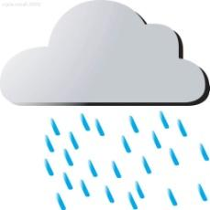 | 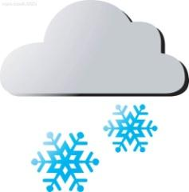 | 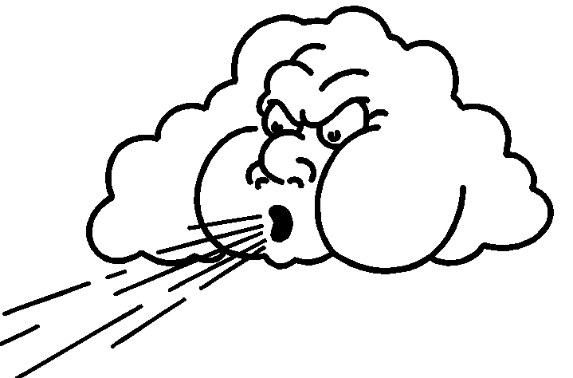

季节：
天气：
气温：

我穿什么衣服?
我穿 ....

第二个国家： ……..的天气怎么样？

季节：
天气：
气温：

我穿什么衣服?
我穿

Find pictures and fill in your suitcase with Chinese descriptions (color+ clothes)
我的衣服：

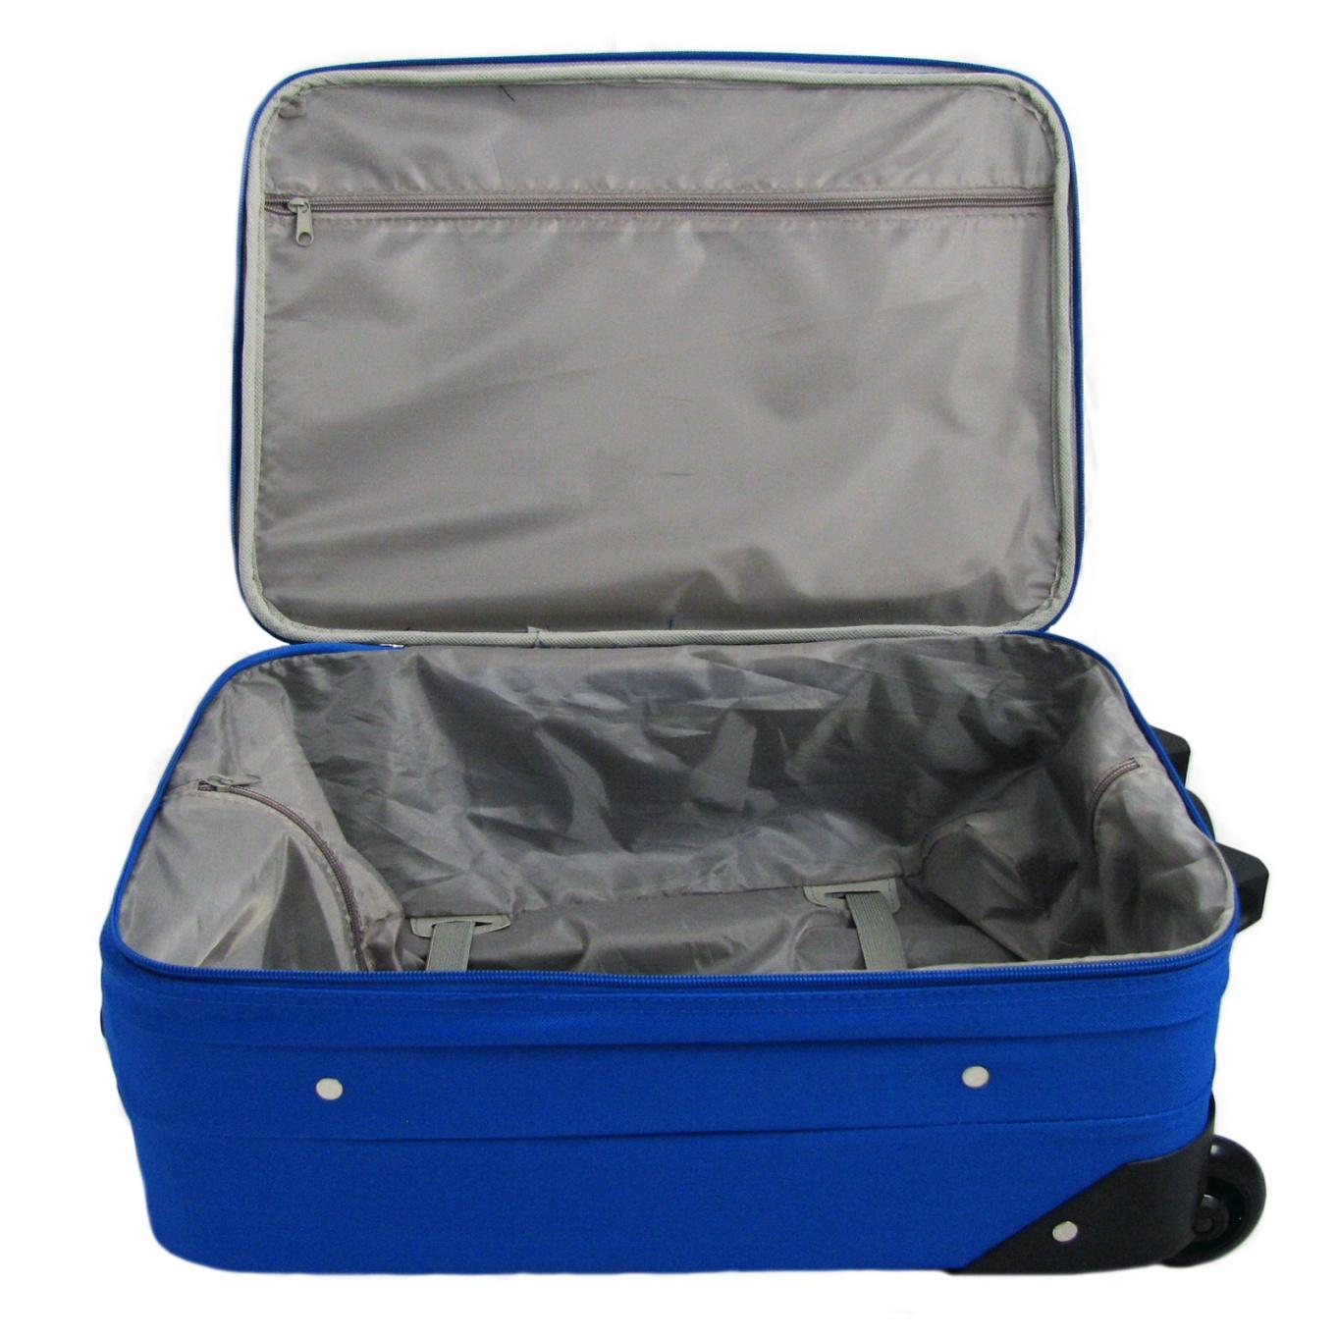
You are going to present your trip poster.

Poster Rubric

CATEGORY | 4 | 3 | 2 | 1
Required Elements | The poster includes all required elements: air tickets and description of your agenda & weather and clothing. | All required elements are included on the poster. | All but 1 of the required elements are included on the poster. | Several required elements were missing.
Labels | All items of importance on the poster are clearly labeled with labels that can be read from at least 3 ft. away. | Almost all items of importance on the poster are clearly labeled with labels that can be read from at least 3 ft. away. | Many items of importance on the poster are clearly labeled with labels that can be read from at least 3 ft. away. | Labels are too small to view OR no important items were labeled.
Additional information | Three areas of additional information is included in the poster. For example: pictures of the local food, celebrities, maps, and things that can remind the reader of that country. | Two areas of additional information is included in the poster. | One areas of additional information is included in the poster. | None additional information is included in the poster.
Attractiveness | The poster is exceptionally attractive in terms of design, layout, and neatness. | The poster is attractive in terms of design, layout and neatness. | The poster is acceptably attractive though it may be a bit messy. | The poster is distractingly messy or very poorly designed. It is not attractive.
Grammar | Only Chinese language is used. There are no grammatical/mechanical mistakes on the poster. | There are 1-2 grammatical/mechanical mistakes on the poster. | There are 3-4 grammatical/mechanical mistakes on the poster. | There are more than 4 grammatical/mechanical mistakes on the poster.

UNIT 2: School Subjects and Phone Conversations
Big Ideas: Students will study subjects of courses in Chinese. By comparing and contrasting American and Chinese school systems, students will have a better understanding of the two systems .
Essential Questions  - What are the major differences between Chinese and American School systems?  - How do you make a phone call in a polite Chinese manner?  Greeting on the phone: 喂，您好，请问您是 哪一位；ask for a person on the phone: 请问，xx在吗； ask the person to call later: 您等一会打来，好吗。 | Enduring Understandings  Students will understand that...  - ask and answer about what subjects one is taking  - Talk about the different parts of American and Chinese school systems: school hours, subjects, student enrollment number for one class, leisure activities  - Discuss what are the same parts of American and Chinese school systems: subjects, class durations, elective classes, and homework  - Use appropriate phone terms when making a Chinese phone call：喂，您好，请问，等一等，对不起，没关系
Areas of Focus: Proficiencies  (Cumulative Progress Indicators)  Students will:  7.1.IL.A.2  Demonstrate comprehension of oral and written instructions connected to daily activities through appropriate responses.  7.1.IL.A.3  Compare and contrast the use of verbal and non-verbal etiquette (i.e., the use of gestures, intonation, and cultural practices) in the target culture(s) and in one’s own culture.  7.1.IL.A.4  Use the target language to describe people, places, objects, and daily activities learned about through oral or written descriptions.  7.1.IL.B.1  Use digital tools to participate in short conversations and to exchange information related to targeted themes.  7.1.IL.B.3  Use appropriate gestures, intonation, and common idiomatic expressions of the target culture(s)/language in familiar situations.  7.1.IL.B.5  Engage in short conversations about personal experiences or events and/or topics studied in other content areas.  7.1.IL.C.1  Use knowledge about cultural products and cultural practices to create a multimedia-rich presentation on targeted themes to be shared virtually with a target language audience.  7.1.IL.C.2  Present student-created and/or authentic short plays, skits, poems, songs, stories, or reports. | Examples, Outcomes, Assessments  Instructional Focus:  - talk about time and when classes are scheduled  - Ask about each other’s schedule (what time to to take what classes)  - phone conversation manners and phrases  - use verbs that are short actions by three different ways: v.v., v.一下， v. 一 v.  - utilize the grammar format 有的是...有的是...还有的是 to describe some are...some are...also some are…  - How to address people appropriately in Chinese culture: 先生，小姐，太太，姐姐，哥哥，弟弟，妹妹  - have an insight of Chinese school system in subjects, class, and school.  - summarize to a Chinese friend what does an American school look like in classes and schedule.  - Study the similarities and differences of the Chinese and American school systems.  Sample Assessments:  - Vocabulary exploration PowerPoint  - Vocabulary quiz on subjects and making a phone call  - Given a new and random scenario card, students will conduct a prompt and unprepared phone conversation oral assessment. E.g. you are calling Meimei, however, the she is not home. Her mum asks you to call back tomorrow.  - Interpretive reading comprehension on a Chinese student’s class schedule.  - Unit test  - Skit Performance: make a phone call to a friend and talk about subjects you are taking this year  Instructional Strategies:  Interpretive:  - Vocabulary exploration PowerPoint  - Watch Chinese School Documentary  - Listen to Chinese phone call conversations and summarize the main ideas of the phone call  - Read a short essay about Chinese school  Interpersonal:  - Interview one classmate and make a class schedule for him/her  - Secret pen pal- every student is going to write a letter talking about the classes he/she is taking. The letter will distribute to a random student in the class. Every student will write back to the pen pal and try to figure out who the writer is.  - Students will get a scenario. Based on it, students need compose a phone conversation.  Presentational:  - Vocabulary exploration PowerPoint  - Vocabulary quiz  - Unit test  - Skit Performance: make a phone call to a friend and talk about subjects you are taking this year  - Schedule poster: students will make a schedule poster in a chart, and then each student writes a description of another student’s schedule.  Interdisciplinary Connections  - Social Studies: the major differences between Chinese and American school systems reflects the cultural differences between the two countries  Technology Integration  - Google Classroom: student submit and present their vocabulary exploration on Google Classroom  - Chromebook voice recording extension- Mic Note to record the phone conversation  - YouTube: watch a documentary of Chinese school system  Global Perspectives  - Some people view Chinese education as a success. Looking at Chinese education system, students will have a better understanding of why and how Chinese students are doing a good job in STEM subjects.  Culturally Responsive Teaching  - The teacher will activate students’ prior knowledge of different school systems in different countries and combine what they know about Chinese school system in order to have a deeper understanding of all types of school systems.

Additional Resources:

Chinese education 中国式教育: https://www.youtube.com/watch?v=B9k6I6dYQCU

Making a phone Call

At the beginning of a school year, you just received your schedule from the school. You are making a phone call to your friend and talking about your schedules. You need to include:
- Use appropriate phone phrases
- Ask about the subjects you are going to take and teachers going to have

Requirements | Points Earned
Vocabulary (at least 15 'out of 20' words from Lesson 3)

Use of prior vocabulary (at least 10 words from prior lessons)

Conversation script must be written
The phone call must follow in Chinese ways

Conversation is fluent

Each team member must have an equal amount of speaking time (at least 1 minute altogether)
Each character must be identified in the phone call (for example: you may decide to be Kobe Bryant calling his agent)

UNIT 3: Hobbies
Big Ideas: Students will look at hobbies in three different aspects and get to know unique and traditional Chinese hobbies. By Comparing and contrasting students will become familiar with the Chinese cultural products and practices.

Essential Questions  - How do you communicate your hobbies or interests with others?  - How does culture influence the hobbies reflective of most Chinese people.  - How do you properly express elapsed time or the duration of activities? | Enduring Understandings  Students will understand that...  - there are hobbies and familiar activities that are common among many cultures. E.g. swimming, playing tennis, and jogging  - there are other hobbies that are specific to a culture. E.g. Chinese Mahjong, walk pet bird, Kungfu Tea  - understanding of the Chinese culture will enhance enjoyment and appreciation of the hobby practice.  - how to express multitasking by using 一边v. 一边v.  - express duration: 你+ v.+ a period of time+ 的+ o.
Areas of Focus: Proficiencies  (Cumulative Progress Indicators)  Students will:  7.1.IL.A.1  Identify the main idea and most supporting details contained in culturally authentic materials using electronic information and other sources related to targeted themes.  7.1.IL.A.2 Demonstrate comprehension of oral and written instructions connected to daily activities through appropriate responses.  7.1.IL.A.4  Use the target language to describe people, places, objects, and daily activities learned about through oral or written descriptions.  7.1.IL.B.1 Use digital tools to participate in short conversations and to exchange information related to targeted themes.  7.1.IL.B.2  Give and follow a series of oral and written directions, commands, and requests for participating in age- and level-appropriate classroom and cultural activities.  7.1.IL.B.3  Use appropriate gestures, intonation, and common idiomatic expressions of the target culture(s)/language in familiar situations.  7.1.IL.B.5 Engage in short conversations about personal experiences or events and/or topics studied in other content areas.  7.1.IL.C.1 Use knowledge about cultural products and cultural practices to create a multimedia-rich presentation on targeted themes to be shared virtually with a target language audience.  7.1.IL.C.3  Use language creatively to respond in writing to a variety of oral or visual prompts.  7.1.IL.C.4  Compare and contrast age- and level-appropriate culturally authentic materials orally and in writing. | Examples, Outcomes, Assessments  Instructional Focus:  - to learn vocabulary, phrases, and sentences to describe hobbies and activities  - compare the differences and similarities of young people’s popular hobbies and activities between US and China  - ask about hobbies in two different ways: 你有什么爱好 and 你的爱好是什么； ask about how often does the person do the hobby: 你+ a period of time+ v.+ 几次+ o. ; how long time it lasts: 你+ v.+ a period of time+ 的+ o.  - to use measure word 个 to help expressing durations  e.g. one and half hours一个半小时; fifteen minutes十五分钟; 3 years三年  - to express the meaning at the time when and what time by using 时候  - to express besides by 除了...以外 at the beginning of the sentence  - to distinguish and be able to use 什么时候 and 几点 in the correct situation  - to express multitasking by using 一边...一边..  Sample Assessments:  - written vocabulary quiz for hobby vocabulary and simple characters  - interpretive reading comprehension of a Chinese student talking about his hobby  - oral assessment - students will be randomly paired up with another student and talk about their hobbies.  - Constant formative assessment  - Unit test  - Make a project summarizing classmates’ hobbies  Instructional Strategies:  Interpretive:  - Learn vocabulary by using TPR  - to learn vocabulary, phrases, and sentences to describe hobbies and activities by making one vocabulary exploration slide, which includes pinyin, pictures, sample sentences, and ways to memorize.  - Students will do multiple hobby reading comprehensions and listening to authentic speakers talking about their hobbies to demonstrate their understanding of the learned vocabulary and grammar.  Interpersonal:  - exchange ideas about Chinese dances  - Interview classmates about their hobbies and how long time it takes for them to do their hobby  - Hobbies taboo- students play a game of taboo where they have to describe and guess hobbies, sports and other free time activities. The aim of the game is for the player to get his/her teammates to say the hobby on a card, but the player cannot say the hobby or the other words on the card.  Presentational:  - talk about three different Chinese traditional dances by using different adjectives and the reasons why they love the dance  - compare the differences and similarities of young people’s popular hobbies and activities between US and China  - Make a project about classmates’ hobbies  - Present every lesson’s vocabulary by making a contribution to one of the vocabulary slides  Interdisciplinary Connections  - Social studies: Students will experience Chinese authentic culture by watching different dances from different areas, enjoying art pieces from different dynasties, and experiencing two traditional Chinese games.  Technology Integration  - Using search engines students can do a research on Chinese traditional hobbies  - Utilize Google classroom and Google slides to prepare vocabulary assignment  - Utilize Quizlet flashcard games to get students familiar with the vocabulary  - Students make one kahoot to assess each other grammar, sentences, and vocabulary  Global Perspectives  - Students will develop appreciation of Chinese culture and understand how Chinese culture affected Chinese people’s hobbies.  - Students will have a better understanding of the Chinese language and culture by trying to experience Chinese hobbies  Culturally Responsive Teaching  - Students will experience cultural differences in American and Chinese cultures. Students can tell similarities and differences between them.  - Provide a list of cultural Chinese hobbies and have students share if they have ever tried it or participates  - Survey students’ hobbies and make a bar graph to compare, which are the most popular in class and see if there is any correlation between students cultural background and their favorite hobbies.  - Ask students about the countries their family are from and share out those hobbies and how long it takes to do them.

Additional Resources:
Chinese checkers： https://www.youtube.com/watch?v=lLai-nARtvw
Water Mountain Painting： https://www.youtube.com/watch?v=OSszFPOX2Pc
Hobbies： https://www.youtube.com/watch?v=7fNVjNAdqX0
Best Crew Dancers: https://www.youtube.com/watch?v=vXzZ_s7Eg4Q
A Thousand Hands Buddiva： https://www.youtube.com/watch?v=aL92LplZZr4
Peacock Dance： https://www.youtube.com/watch?v=LvhBwwuEGS4
Xin Jiang Dance： https://www.youtube.com/watch?v=F5-0sCP5uTo
Fan Dance： https://www.youtube.com/watch?v=xeuGfHJeDrc

Four Tables
Four tables include listening, speaking, reading, and writing sessions. You are going to finish every session in two periods.

Listening: a: 男 bc：女
A: 你好，请问黄医生在吗？
B: 请等一等，我去叫她。

C：你好，请问您是哪一位？
A：黄医生，您好。我是您的病人天天。
C: 哦， 天天你好！你哪儿不舒服吗？
A： 我今天早上起床头很痛，还发烧。我很想睡觉。
C： 天天，你感冒了吗？你今天下午来看医生好吗？
A：我妈妈几点带我去看医生？
C：三点半好吗？
A：三点半妈妈没下班。四点半好吗？
C：好的。四点见！

Four Tables

2. Listening and Speaking: (10 points)

Talk about Tiantian’s phone conversation: (record the asking and answer questions)
天天跟谁打电话？
天天生病了吗？他哪儿不舒服？
天天什么时候去看医生？
天天几点去看医生？
天天和谁去看医生？

Reading +Writing: (10 points)
昨天的天气：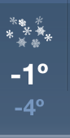
天天住在北京。北京一年有四个季节。那里的三月、四月、五月是春天。六月、七月、八月是夏天。九月、十月、十一月是秋天。十二月、一月、二月是冬天。北京的春天常常刮风。夏天非常热。天天最喜欢北京的秋天。秋天很美，不冷也不热。现在北京是冬天。天天最不喜欢冬天，常常下雪。

According to the listening, speaking, and reading materials, please write two short paragraphs:

Paragraph one:Tiantian is writing an email to tell his friend about he being sick after a snow day and the experience of seeing a doctor. (10 sentences)

Paragraph two: Tiantian is making a pamphlet to promote living in Beijing. You may do a research online and try to write a short paragraph talking about benefits of living in Beijing. (5 sentences)

UNIT 4: Food
Big Ideas: In this unit, students will talk about fruits, vegetables, and Chinese food by talking about cooking methods, role playing in a Chinese restaurant, and presenting their own supermarket of fruits and vegetables.

Essential Questions  - What is a “typical meal” in China?  Students will study three typical meals in China and they will summarize what the meals look like.  - What makes Chinese cuisine special?  - How are the culture and food of Chinese related?  - What is Chinese currency system and weight system?- RenMinBi and metric system  - How to use the following measure words with the appropriate noun categories? 口，个，家，种，位，台，朵，斤，门，双，条，头，顶，把，张，本  - How to bargain in Chinese?  as the buyer: 我没有钱；便宜一点；太贵了  as the seller: 你要买什么，不贵不贵，你想多少钱 | Enduring Understandings  Students will understand that...  - give suggestions by using different suggestion words in various situations: 应该，可以，吧  - Categorize food into five subcategories in Chinese：谷物，蛋白质，水果，蔬菜，奶制品  - Use sixteen measure words with the appropriate noun categories- 口，个，家，种，位，台，朵，斤，门，双，条，头，顶，把，张，本  - use 或者 or 还是 (both of them mean or ) in different situations.  - express future intend by using 会/要+v.  - Through video and visual materials, students will see how Chinese food are different in table manners, dish setup, and many detailed things.
Areas of Focus: Proficiencies  (Cumulative Progress Indicators)  Students will:  7.1.IL.A.1  Identify the main idea and most supporting details contained in culturally authentic materials using electronic information and other sources related to targeted themes.  7.1.IL.A.2  Demonstrate comprehension of oral and written instructions connected to daily activities through appropriate responses.  7.1.IL.A.3  Compare and contrast the use of verbal and non-verbal etiquette (i.e., the use of gestures, intonation, and cultural practices) in the target culture(s) and in one’s own culture.  7.1.IL.A.4  Use the target language to describe people, places, objects, and daily activities learned about through oral or written descriptions.  7.1.IL.B.1  Use digital tools to participate in short conversations and to exchange information related to targeted themes.  7.1.IL.B.5  Engage in short conversations about personal experiences or events and/or topics studied in other content areas.  7.1.IL.C.1  Use knowledge about cultural products and cultural practices to create a multimedia-rich presentation on targeted themes to be shared virtually with a target language audience.  7.1.IL.C.2  Present student-created and/or authentic short plays, skits, poems, songs, stories, or reports. | Examples, Outcomes, Assessments  Instructional Focus:  - Vocabulary about vegetables and fruits and commonly seen American and Chinese food.  - Apply the appropriate suggestion words in different situations  - Express “future tense” by using a future time + 会、要  - Convert some of the American measure system to the metric system  - Bargain as a seller and a buyer by using appropriate expressions  - Use learned measure words appropriately before nouns  - Narrate one Chinese stir-fry dish cooking process  Sample Assessments:  - Group project: tea party grocery shopping with supermarket catalogues  - Food vocabulary and simple characters quiz and sentence construction quiz  - Oral assessment: given objects, students will bargain as a seller and a buyer  - Restaurant skit: students are going to write a bargaining skit and act it out.  Instructional Strategies:  Interpretive:  - Exit tickets on vocabulary presentation  - Students will study three typical meals in China and they will summarize what the meals look like.  - Given pictures, students will compare and contrast typical American and Chinese school lunch  Interpersonal:  - Compare and contrast typical American and Chinese school lunch  - Discussion: you like Chinese food or American food? Why?  - Interview: What is your favorite fruit, vegetable, and dish?  - Practice the bargaining skit  Presentational:  - Sing a veggie and fruit rap song  - Write and Perform a restaurant skit  - Group project: tea party grocery shopping with supermarket catalogue  - Vocabulary presentation for every lesson  - Narrate one chinese stir-fry dish cooking process  Interdisciplinary Connections  - Social Studies: students will have a better understanding of traditional Chinese food culture  - Art: Students will describe physical appearance using descriptive language and learn about Chinese food.  - Math: students will convert Amercan measure system to Chinese measure system.  Technology Integration  - Authentic Chinese documentary “A Bit of China”  - Utilize Google classroom and Google slides to prepare vocabulary assignment  - Utilize Quizlet flashcard games to get students familiar with the vocabulary  - Students make one kahoot to assess each other grammar, sentences, and vocabulary  Global Perspectives  - Students will be presented with various foods from China and those specific to Chinese culture.  - Students will relate things they see to Chinese culture and values.  Culturally Responsive Teaching  - ask students to share about traditional food from their culture and have a general understanding of Chinese traditional food  - compare Chinese food and American food

Additional Resource:
怎么煮pasta： https://www.youtube.com/watch?v=a7hH1jN59HY
炒菜 order ： https://www.youtube.com/watch?v=YDtdKNajnP4
Chinese class 101 水果： https://www.youtube.com/watch?v=09p6Ae_02-s&index=2&list=PL9DE19DD1A9882A9B
做水果沙拉 order： https://www.youtube.com/watch?v=3fnUYVYnqgo
舌尖的中国（主食）：https://www.youtube.com/watch?v=PCgYUKPNCug
舌尖的中国 厨房的秘密:https://www.youtube.com/watch?v=EJVRG68_cZI&list=PLodP2yDwGRJHDoEGcR4P3iSwow4YGaur_&index=5 舌尖上的中国 一日三餐： https://www.youtube.com/watch?v=S0oriKFY08w
会、能、可以： https://www.youtube.com/watch?v=iXzP2Lw9ais

You went to a Chinese restaurant. You ordered food and had a wonderful meal. However, you found you did not take enough money with you and you want to ask the waiter to reduce the price for you.

Bargaining in a Restaurant Skit
名字:______________________________________________________

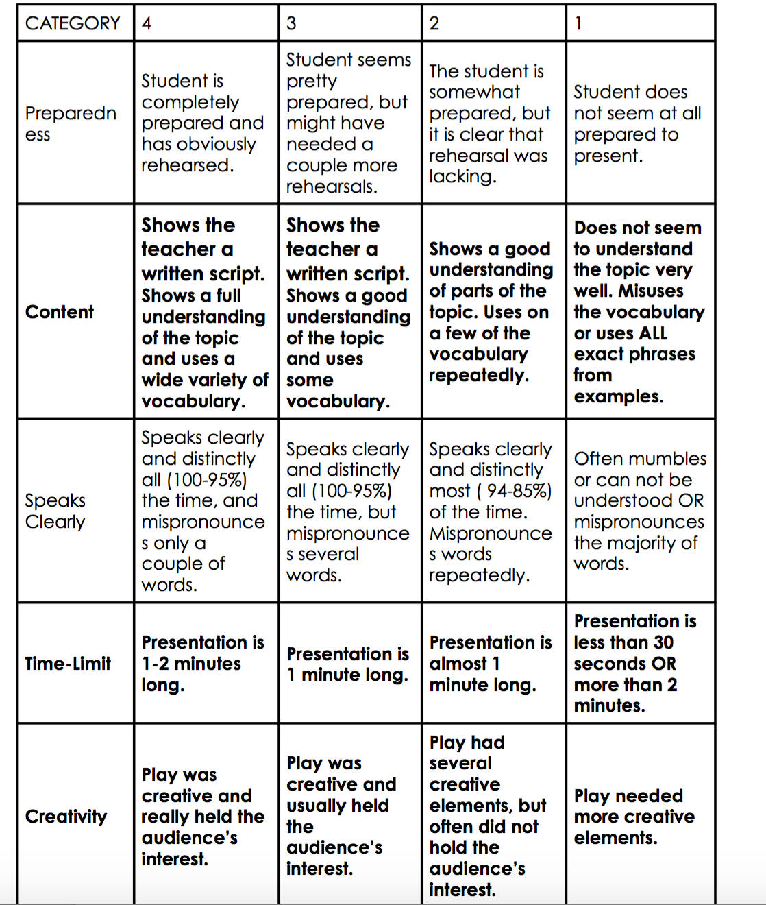

UNIT 5: Community
Big Ideas: By learning this unit, students will have a better understanding of what a community is; what they can do in their community; and how to describe a community in Chinese. They will be able to introduce their town to Chinese speaking people.

Essential Questions  - What is a community?  - How to tell and ask about location?  Ask location: P1在P的X边? P1的X边是什么?  Tell location:P1 在 P2 的X边。 P1的X边是P2.  - What can I do in my community?  - How can I describe my community? | Enduring Understandings  Students will understand that...  - express distance by using P1离P2+distance/time  - Talk about relative location by telling P1 在 P2 的X边。 P1的X边是P2.  - They can describe relative location by using an object as a reference  - Use sequence words to state first（先）, then（再）, and then（然后） when narrating a story  - Students need to use the sentence structure: Person+ Time+ Place+ Verb to talk about what they do in their community
Areas of Focus: Proficiencies  (Cumulative Progress Indicators)  Students will:  7.1.IL.A.2  Demonstrate comprehension of oral and written instructions connected to daily activities through appropriate responses.  7.1.IL.A.3  Compare and contrast the use of verbal and non-verbal etiquette (i.e., the use of gestures, intonation, and cultural practices) in the target culture(s) and in one’s own culture.  7.1.IL.A.4  Use the target language to describe people, places, objects, and daily activities learned about through oral or written descriptions.  7.1.IL.B.1  Use digital tools to participate in short conversations and to exchange information related to targeted themes.  7.1.IL.B.3  Use appropriate gestures, intonation, and common idiomatic expressions of the target culture(s)/language in familiar situations.  7.1.IL.B.5  Engage in short conversations about personal experiences or events and/or topics studied in other content areas.  7.1.IL.C.1  Use knowledge about cultural products and cultural practices to create a multimedia-rich presentation on targeted themes to be shared virtually with a target language audience.  7.1.IL.C.2  Present student-created and/or authentic short plays, skits, poems, songs, stories, or reports. | Examples, Outcomes, Assessments  Instructional Focus:  - Student will be able to state public facilities do they have in their community?  - Describe a house by talking about rooms, furniture, and location of the town  - Ask and answer how to go to a place  - Identify Vocabulary about house, furniture, and community  - express distance by using P1离P2+distance/time  - Describe relative location by using an object as a reference- P1 在 P2 的X边。 P1的X边是P2.  - Ask and answer how to go to a place  - Use sequence word when narrating a story -先，然后，再  - Make a project introducing your town  - Students will use at least five adjectives to describe their community. They need to elaborate each idea in more than one sentence.  Sample Assessments:  - House, furniture, and community vocabulary, simple characters, and sentence construction quiz  - Students will create their own dream house in an ideal community. They need to convince their peers that their house is the best house in the community.  - Unit test  - Skit: given a map, students will be conducting a conversation asking and answering location and what to do there  - Project: choose from the given formats, students need to present their town  Instructional Strategies:  Interpretive:  - Students will get a better understanding of the vocabulary about house, furniture, and community by comprehending the vocabulary exploration presentations from their peers.  - Using a map of Summit, students need to discuss the relative location of certain community landmarks such as Magic Fountain, The YMCA, the train station, the Summit Medical Center in relation to our school. 在xx的x边；x的x边是x.  Interpersonal:  - Given a map, students can ask and answer how to go to a place  - Interview: What is your ideal house? You should include your rooms, appliances in the house, and location of your house.  - Discussion: what improvements we should get to make our town a better place to live? Why is it?  Presentational:  - My Town Project: students are making a map including 8 landmarks (such as school/ supermarket).The city has a town center and many services that are necessary for people who live in this town. Also, students need to make a pamphlet or brochure to advertise their house, including price, house structure, rooms, property attaching to the house, location in the town  - Use sequence words to state first, the, and then 先，然后，再 when narrating a story. Students will sequence photos of a story as I read it to them. Then they will try to sequence photos in their own way to make up a story and present it to the class.  Interdisciplinary Connections  - Social Studies: Chinese people share the same community concept as American people do.  Technology Integration  - Using search engines students can do study a real Chinese community  - Make a powerpoint, video, or a poster to display your town.  - Utilize Google classroom and Google slides to prepare vocabulary assignment  - Utilize Quizlet flashcard games to get students familiar with the vocabulary  - Students make one kahoot to assess each other grammar, sentences, and vocabulary  Global Perspectives  - Students will have an insight into Chinese community and American community.  - Students will understand the differences of housing between Chinese and American styles  - Students will see many different technologies applied in home appliances in Chinese families that are very trendy and handy, which was a proof of rapid growth of Chinese technology.  Culturally Responsive Teaching  - Students will share what their home countries’ communities look like. With the knowledge of a Chinese community and the experience of an American community, what are the similarities and differences among them; which one they like better and why.

Additional Resources:
量词： https://www.youtube.com/watch?v=bTHwxnkom0E
讨价还价（租房子）： https://www.youtube.com/watch?v=Y7VGsPfZ2-g
milano家具： https://www.youtube.com/watch?v=E6UEXtzqsyE

Our Town
You want to advocate for our Summit City. You want to make a flyer, video, or a photo book to help people understand your town. You are going to present your project talking about the landmarks you introduced in the project. You have to include four parts in your project:

Requirements | Excellent  5 Points | Good  3 Points | Average  1 Point
Landmarks | The map includes 8 landmarks (such as School/supermarket).The city has a town center and many services that are necessary for people who live in this town. | The map includes fewer than 5 landmarks. There is no town center. Services are necessary to run a city are present, a few are missing. | This map does not include landmarks. Services that are necessary to run a city are not present.
Expression of Ideas | Addresses the prompt appropriately and completely. Responds to prompt knowledgeably and accurately. REsponse consistently demonstrates awareness of audience. | Addresses the prompt adequately. Responds to prompt in a general manner. Response may demonstrate limited awareness of audience at times. | Addresses the prompt inadequately or inappropriately. Response to prompt may be off-topic or incomplete. Response demonstrates little or no awareness of audience.
Your House | You need to make a pamphlet or brochure to advertise the house, including price, house structure, rooms, property attaching to the house, location in the town. | Your pamphlet or brochure has five of these:including price, house structure, rooms, property attaching to the house, location in the town. | Your pamphlet or brochure has three of these:including price, house structure, rooms, property attaching to the house, location in the town.
Grammar | Consistently employs correct and appropriate grammar. Errors are minimal or do not interfere with meaning. | Generally employs adequate grammar. Errors may be frequent and may interfere with meaning. | Employs only basic grammar, or grammar use is inadequate. Errors may cause the response to be incomprehensible.

